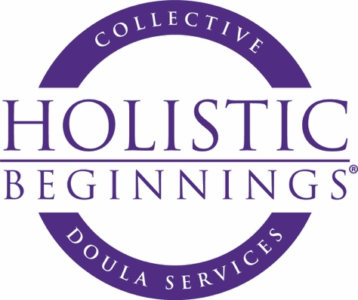

Name

Address

Phone

Email

Age Due Date

Who is your medical provider?

May I discuss you with your medical provider?

Who will be your partner at your birth?

Where are you planning to give birth?

What is your budget for doula services?

Have you or will you be taking Childbirth Preparation Classes? If yes, which type and
with whom?

Do you have any special needs during your pregnancy and/or birth? If so, what are they? Do you have any illnesses that you anticipate will complicate your birth?

What is your past experience(s) with hospitals?

Why do you want a labor doula ?

What do you anticipate will be you emotional needs during labor.

What are your fears or concerns regarding the rest of your pregnancy, labor, birth and postpartum.

If this is not your first birth, please describe in detail your previous births. Please use the back of this paper or attach.

Have you had any periods of mental illness, depression, anxiety disorder or previous postpartum depression that you care to share with me?

Describe your relationship with your parents.

Describe what your ideal birth would be? Use the back of paper if necessary.

Do you think labor will hurt?

Are you afraid of the pain?
How do you ordinarily deal with pain? How do you see yourself coping with pain during labor?

Where do you usually hold tension in your body when under stress?

Do you wish to avoid pain medication.

What are some specific desires you have for this birth? You may attach a birth plan if you have one written.

Do you have any cultural , religious or spiritual needs that you would like to share with me?

How do you plan to feed your baby?

